**Experiment 2**

* Use of appropriate command to determine your login shell.

To find all available shells in your system type by using appropriate command.

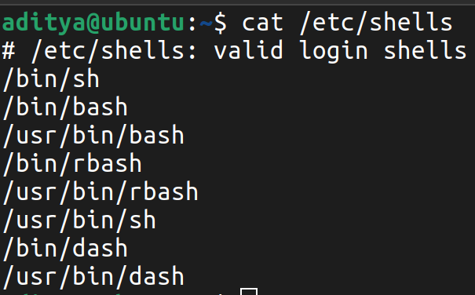

Use the /etc/passwd file to verify the result of part (B).

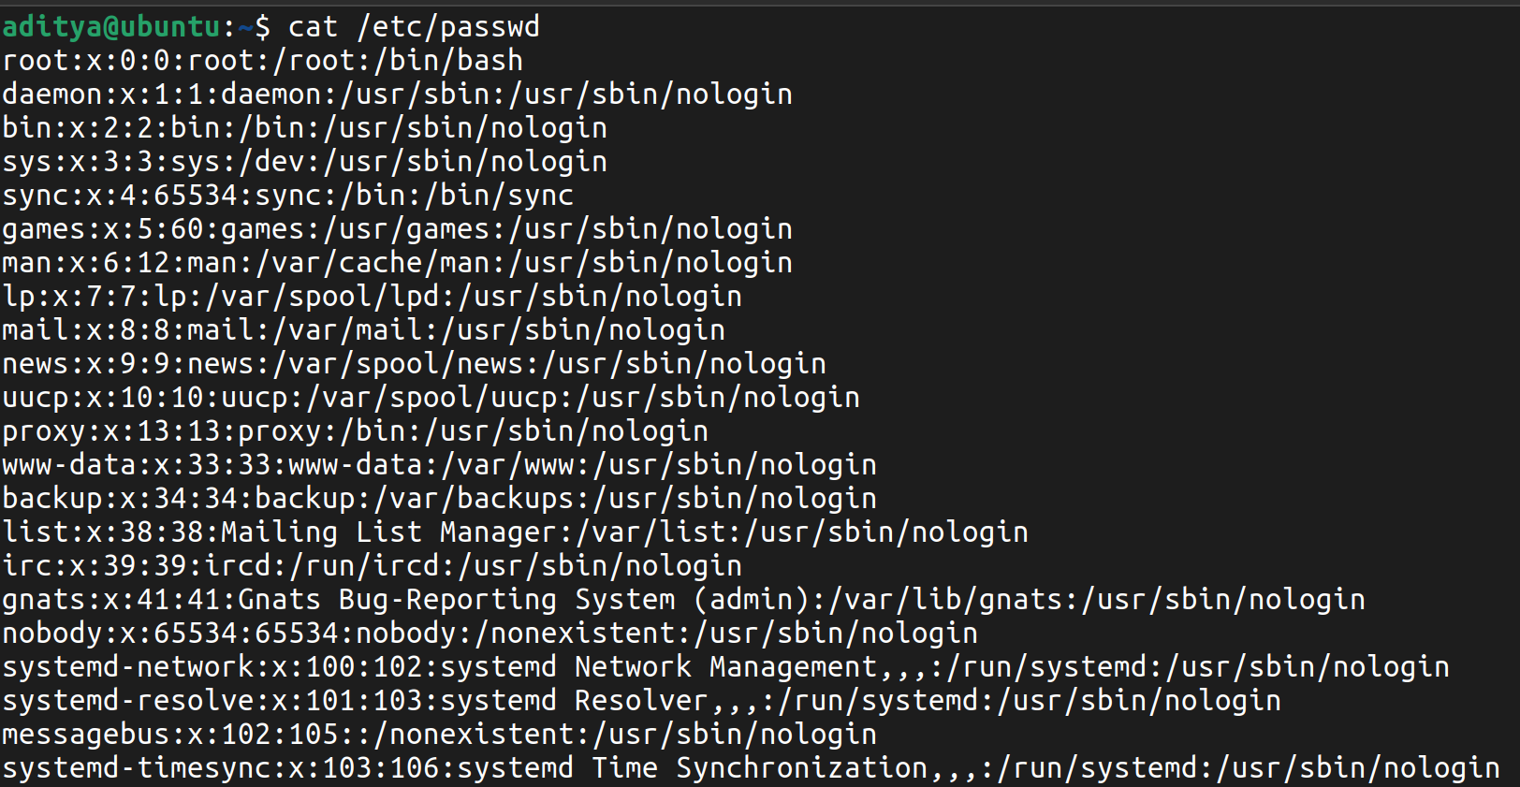

* Use the date and who commands, in one line, such that the output of date is displayed on the screen and the output of who is redirected to a file. Use the more command to check the content of that file.

Write a sed command that swaps the first and second words in each line in a file.

